**Exploring Weather Trends - Project Instructions**

* Write a SQL query to extract the city level data. Export to CSV.
* select year,city,avg_temp from city_data where city ='Bangalore'
* Write a SQL query to extract the global data. Export to CSV.
* select * from global_data

I wrote the above queries in SQL workspace provided in our udacity portal , then downloaded the CSV.

Then Used that data to calculate the moving averages.

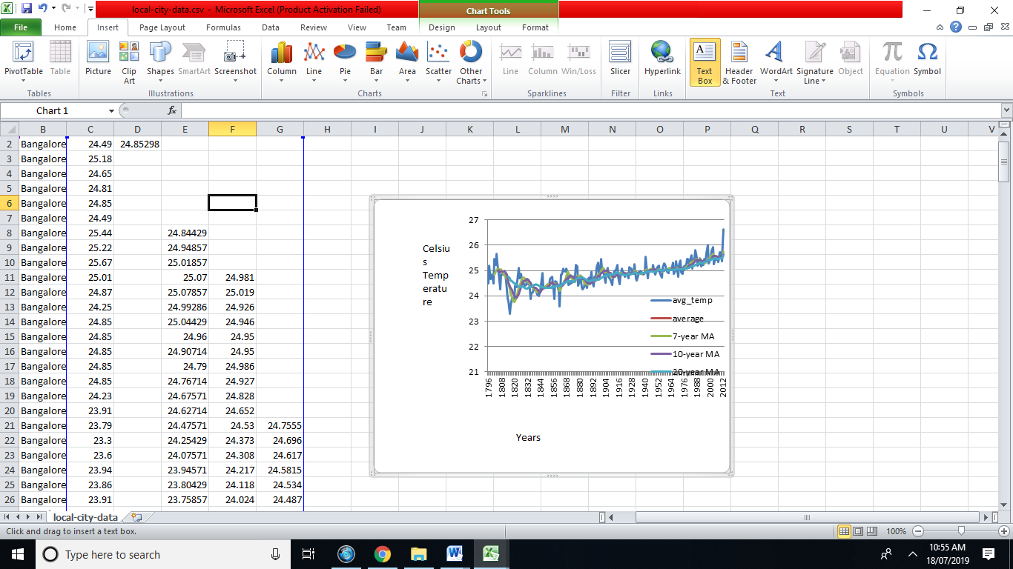

Second query yieled global data.

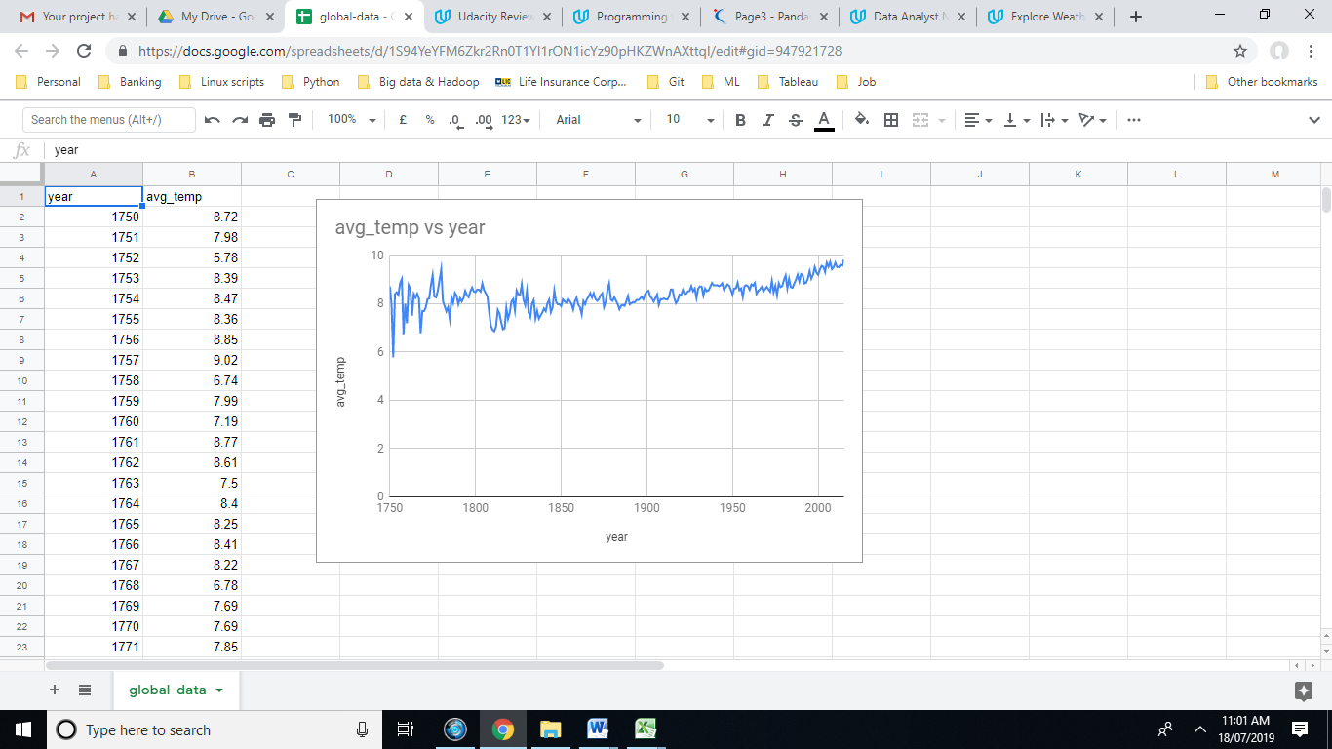

Observation:

Global average temperature varies between 8.72 to 9.83 degree Celsius. But Bangaloreaverage temperature varies between 24.49 to 26.61.

When comparing Bangalore average temperature with global average temperature then Bangalore average temperature is getting hotter than global average temperature.

According to the graph and the table the difference between global and Bangalore temperature over the period of the time has been steadily increasing and the increase from year 1992 has been more.

Bangalore average temperature for all years stated is 24.805. Calculation has been done for every 5 year MA, 10 year MA and 20 year MA. There is a steady increase in temperatures during those period.

From above line chart there has been global temperature directly proportional to increase in Bangalore city average temperature.

Final conclusion is that Bangalore city is getting hotter and also world temperature is also getting hotter as years increase.